**DATA ANALYTICS WITH MONGODB**

**DELIVERY HERO**

**TASK 1:-**

Creating a database named DeliveryHero with a collection called delivery.

**TASK 2:-**

**#No.of restaurants in each region**

We select,

PROJECT:- *{"address line 2":1,RestaurantName:1}*

SORT:- *{"address line 2":1}*

Exporting as delivery.csv

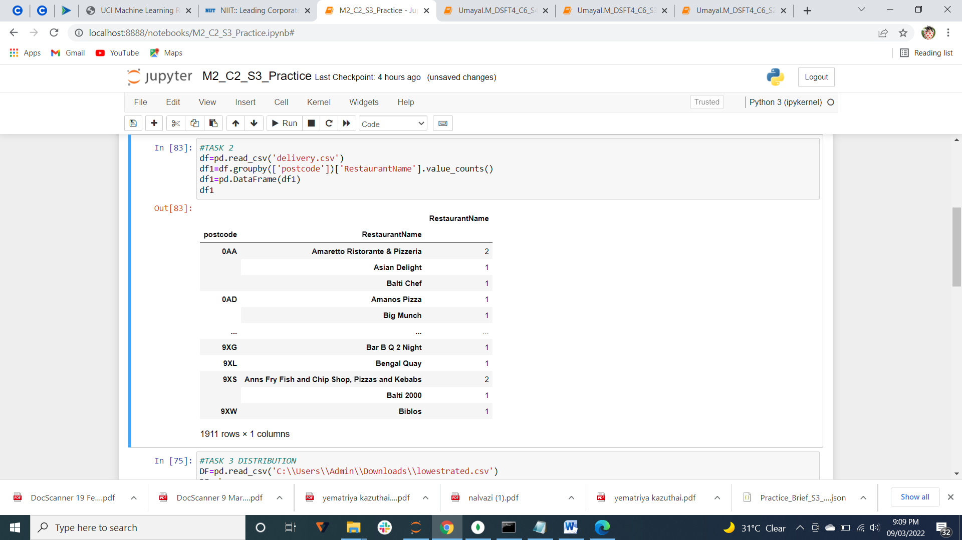

No.of records=1911

**TASK 3:-**

**#distribution of food type in each region**

Finding the distribution between type of food and postcode

PROJECT:- *{"address line 2":1,postcode:1,type_of_food:1}*

Using exported csv file delivery.csv

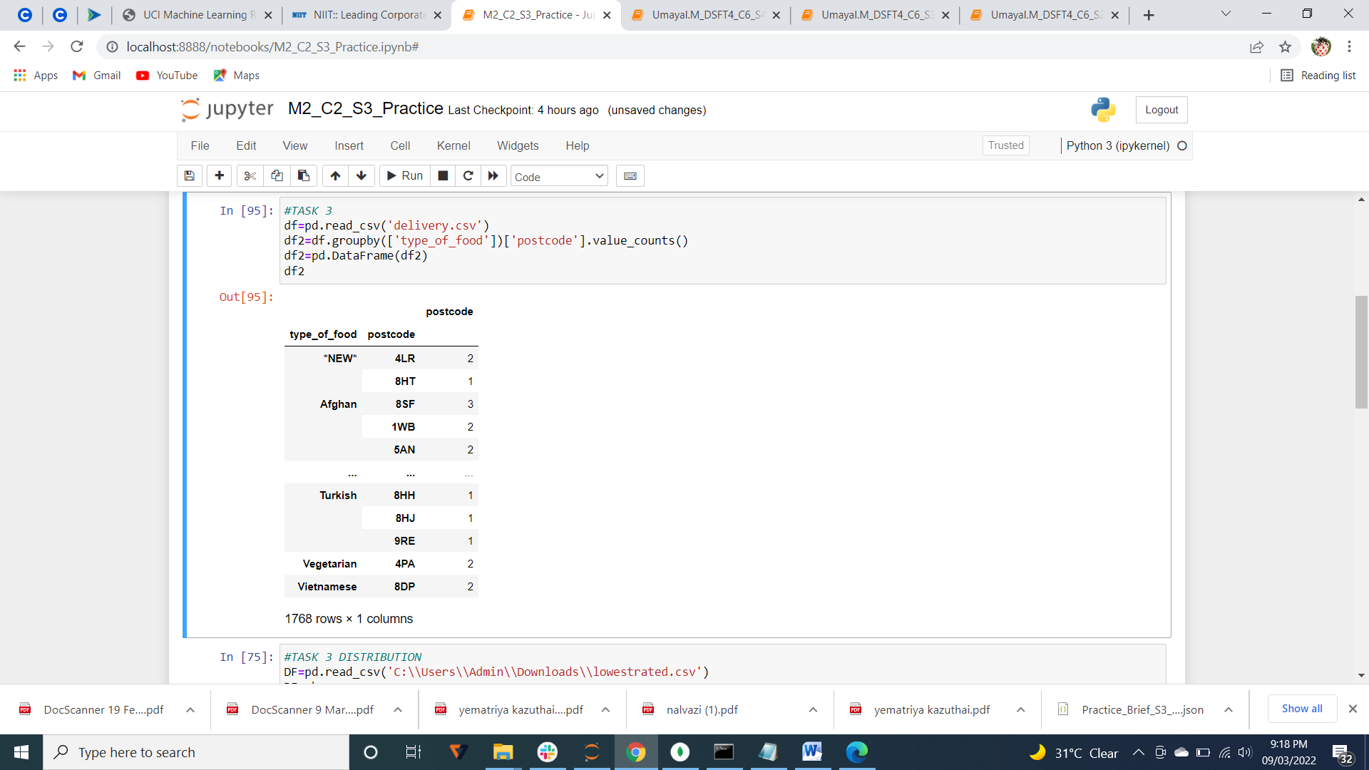

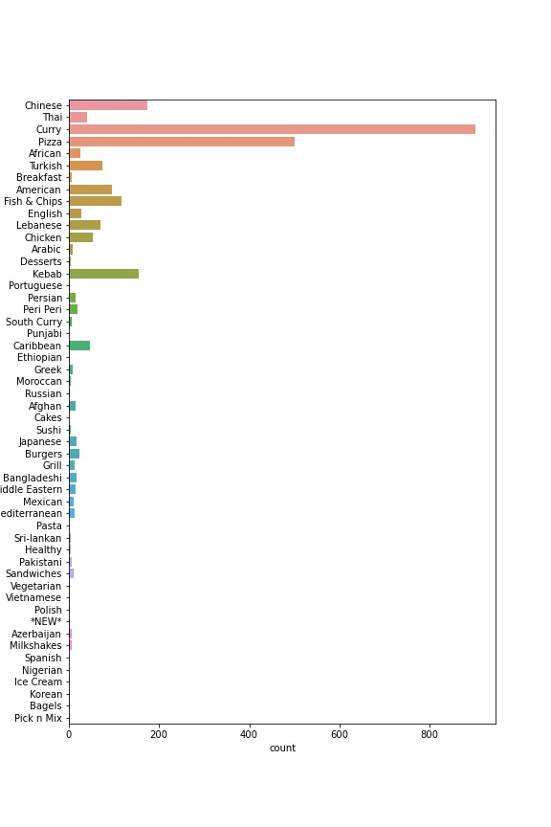

**TASK 4:-**

**#lowest rating**

FILTER:-  *{$or:[{rating:1},{rating:2}]}*

SORT:- *{rating:-1}*

Exported as lowestrated.csv

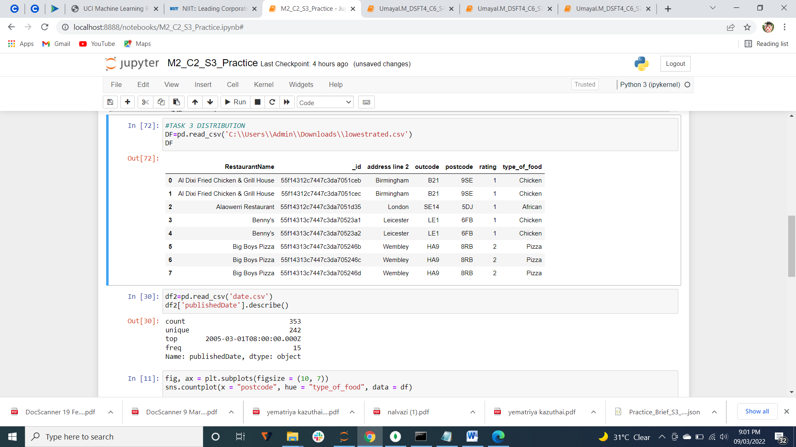

No.of records=8

**TASK 5:-**

**#highest rating with food type**

FILTER:-  *{rating:{$gte:6}}*

PROJECT:- {rating:1,type_of_food:1}

Exported as foodtype.csv

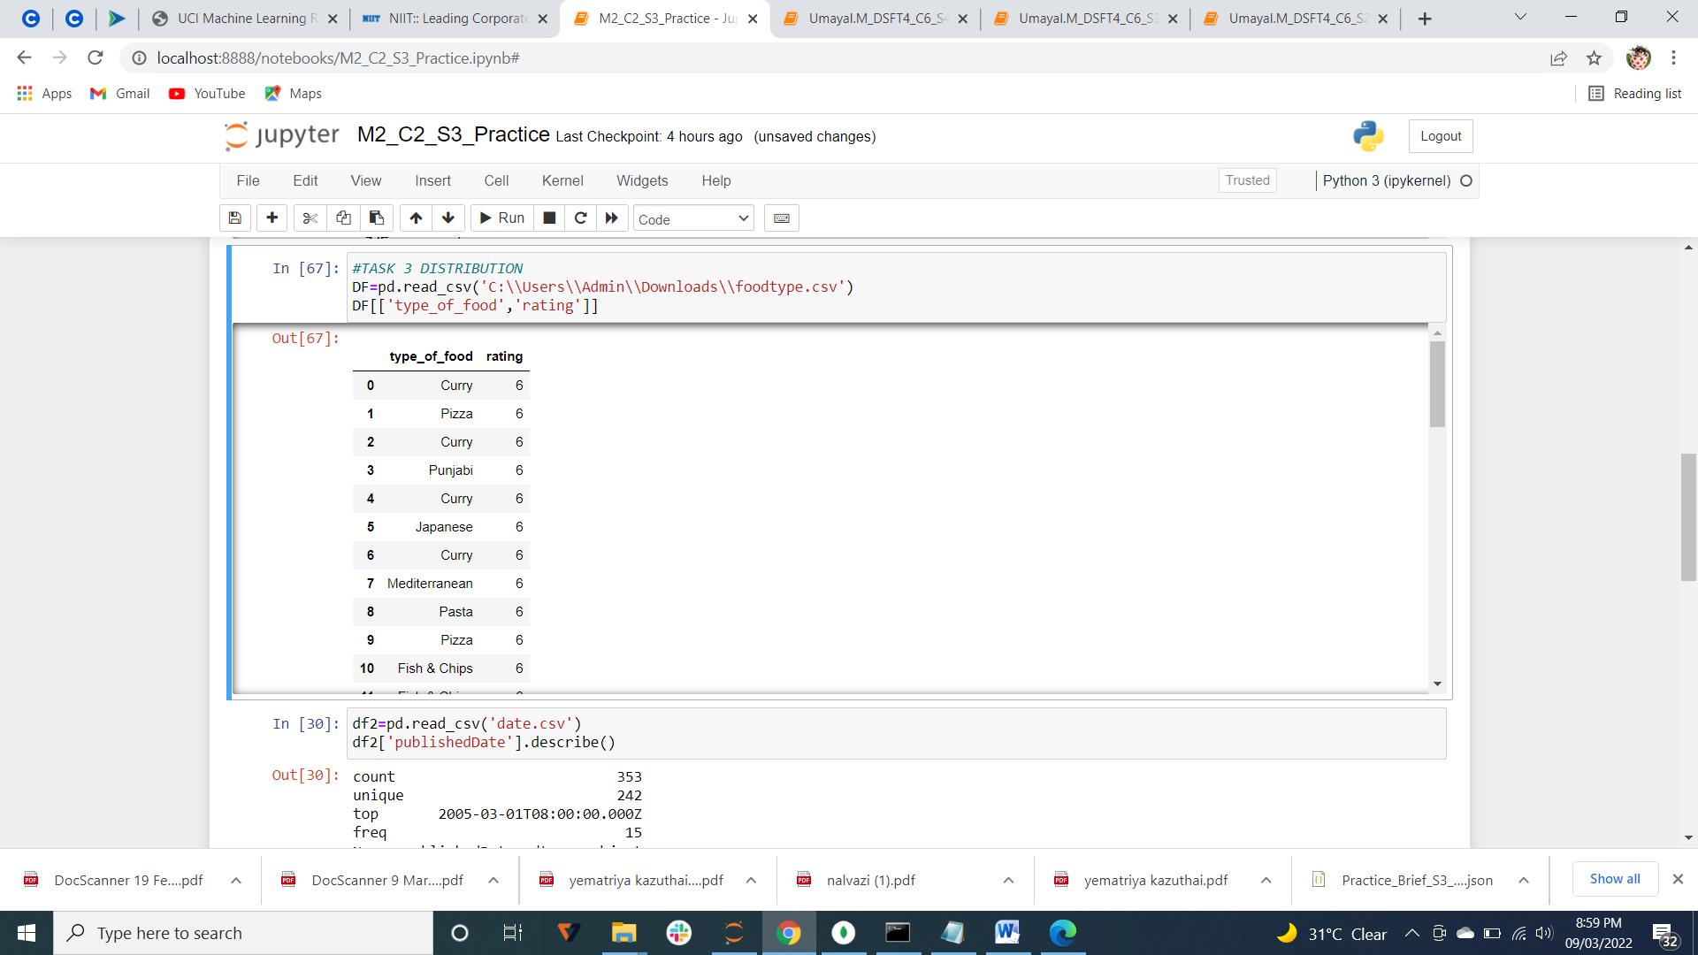

No.of records=49

**TASK 6:-**

**#less than average rating**

Average=3.5

FILTER*:- {rating:{$lt:3.5}}*

Exported as low.csv

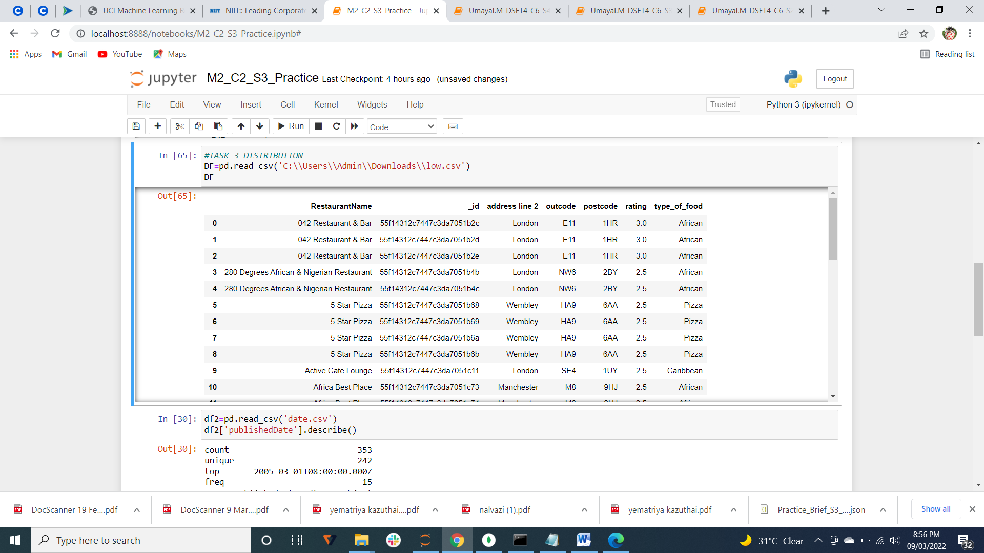

No.of records=39

**TASK 7:-**

**#Name of restautant should be in type_of_food and country**

FILTER:- *{$or:[{RestaurantName:{$regex:/African/}},{RestaurantName:{$regex:/American/}},{RestaurantName:{$regex:/Chinese/}}]}*

Exporting as AmAfCh.csv

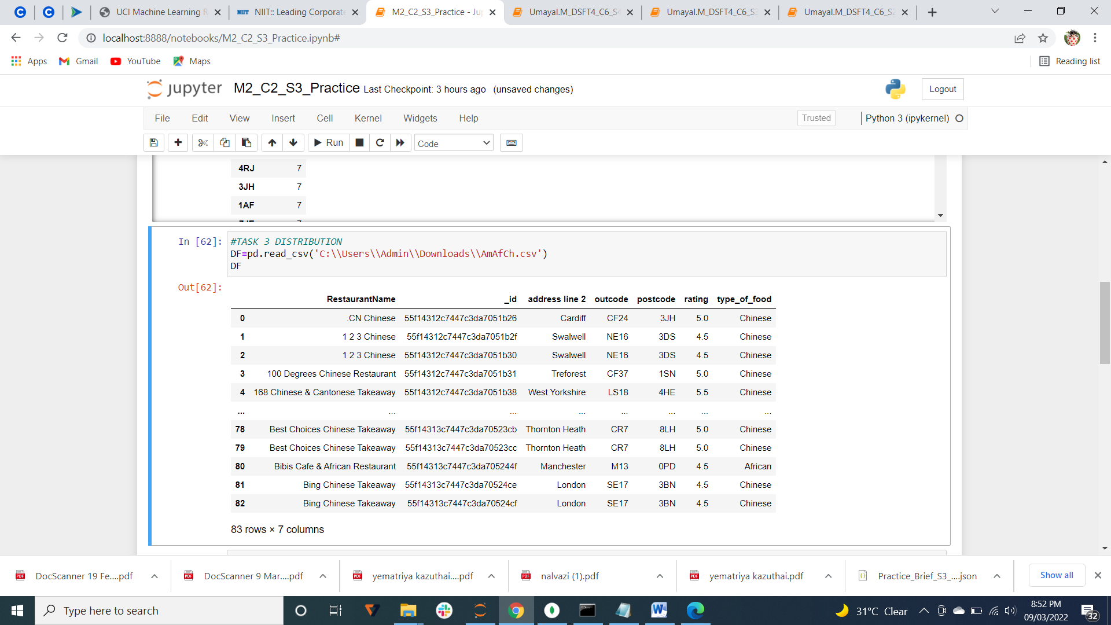

No.of records=83

FILTER:-

*{$or:[{RestaurantName:{$regex:/Korean/}},{RestaurantName:{$regex:/Japenese/}},{RestaurantName:{$regex:/Thai/}}]}*

Exporting as ThJaKor.csv

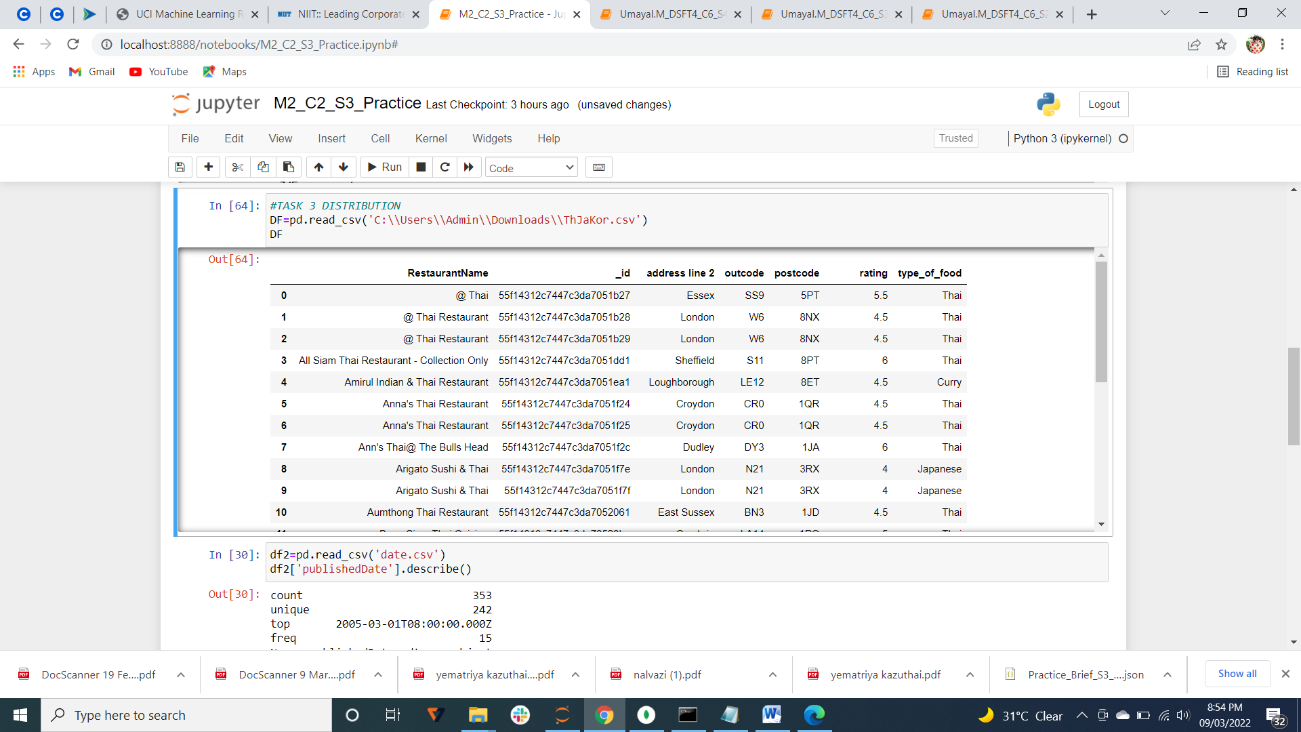

No.of records=26

**LIBRARY**

**TASK 1:-**

Creating a database called Library with a collection called Books.

**TASK 2:-**

PROJECT:- *{_id:1,isbn:1,Book_name:1,writers:1}*

Considering only these 4 headings.

**TASK 3:-**

**#most popular author**

Exporting as auth_pop.csv

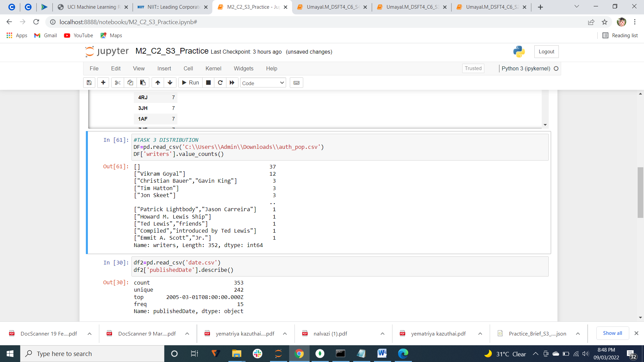

Vikram Goyal is the most popular author

**TASK 4:-**

**#most and least trending category books**

PROJECT:- *{_id:1,isbn:1,Book_name:1,writers:1,categories:1}*

Exporting as cat.csv

Internet is the most trending category of the books.

PHP , software development, Algorithmic Art ,Next generation database and XML

are some of the least trending category of books.

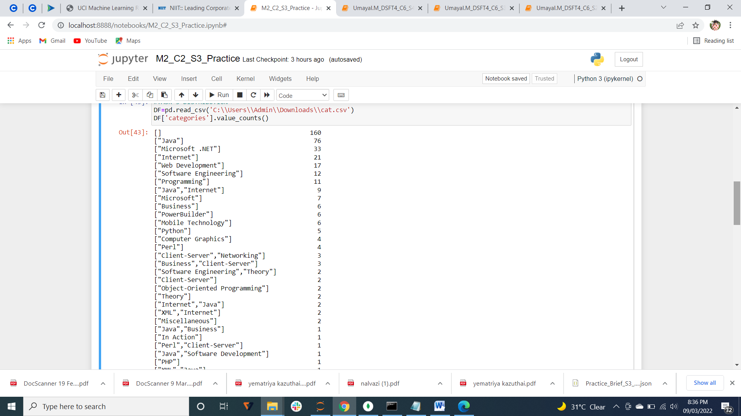

**TASK 5:-**

**#author name**

For author name , we can see auth.csv which is exported.

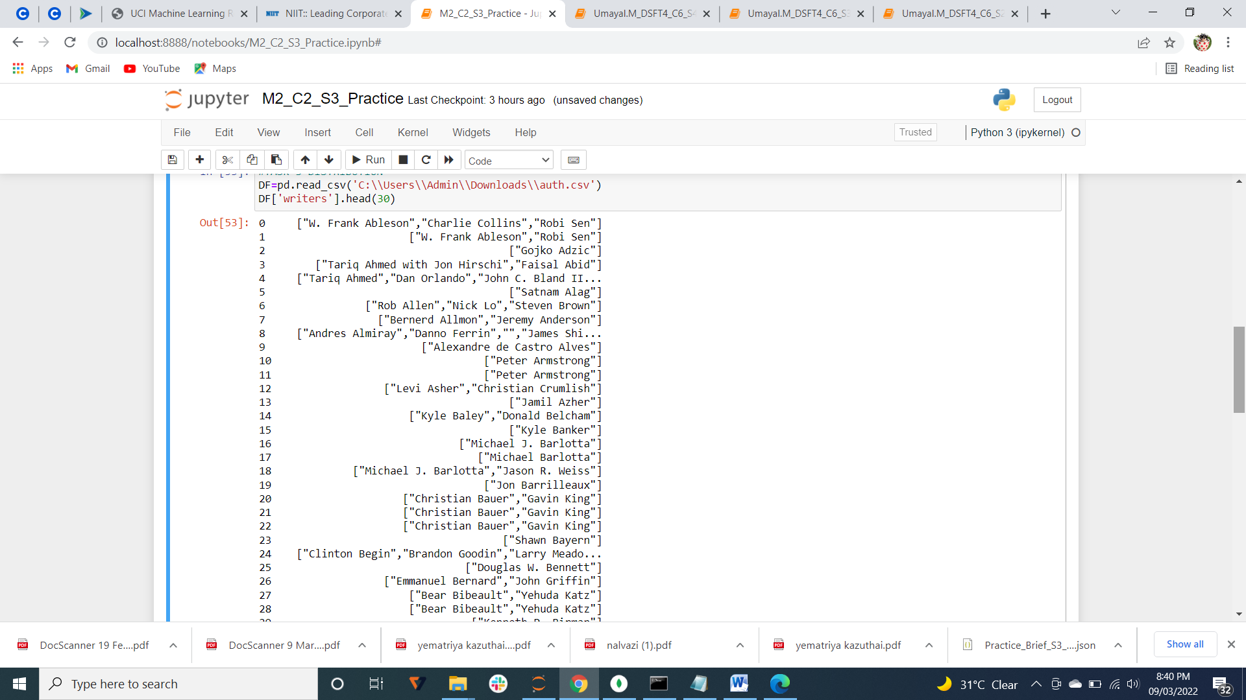

**TASK 6:-**

**#various book category and most trending category**

Exporting as cat.csv



Java is the most trending category of the books.

**TASK 7:-**

**#preferred date for publish books**

Filter:- *{status:"PUBLISH"}*

Exporting as date.csv

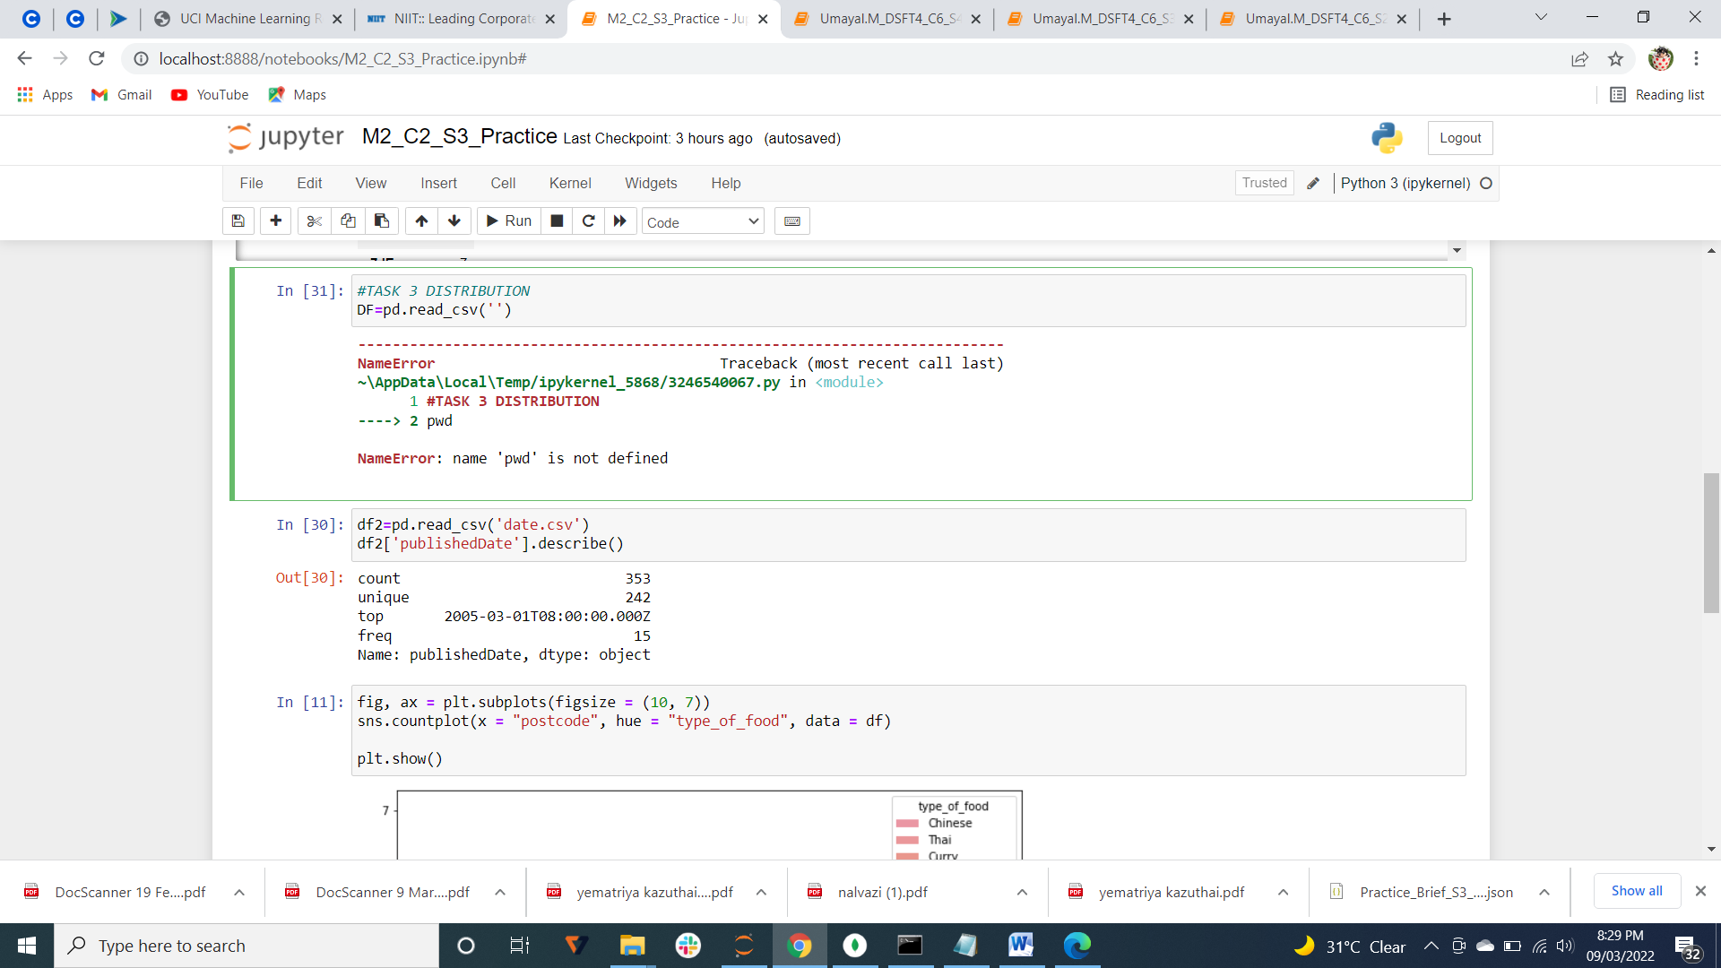

Preferred date= 2005-03-01T08:00:00.000Z

**TASK 8:-**

**#book title with short description**

PROJECT:- *{Book_name:1,shortDescription:1}*

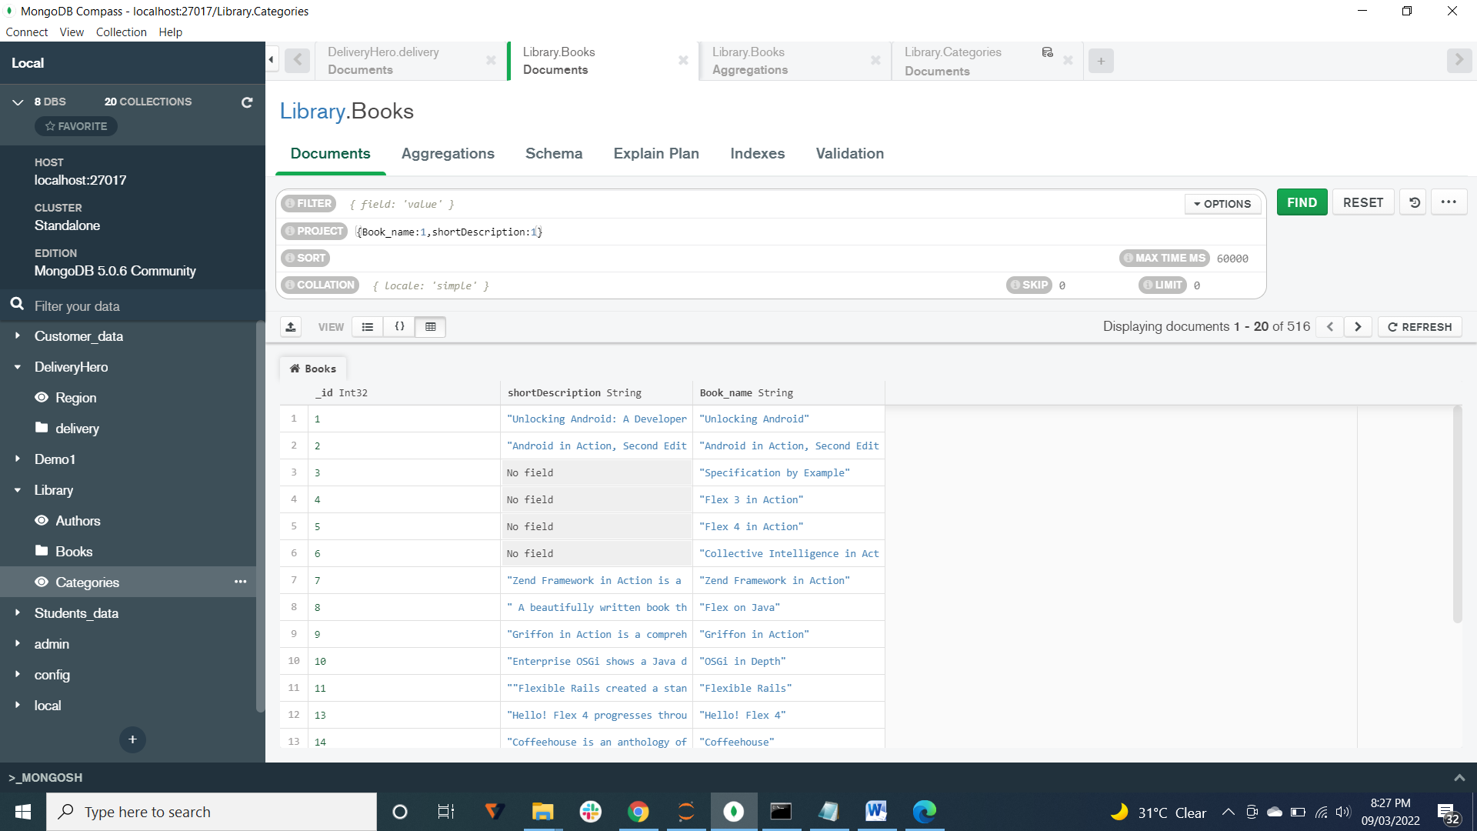

**TASK 9:-**

**#group authors according to their book collection**

Creating separate collection for AUTHORS and book1

Using aggregations,

1. $unwind

*{*

*path: '$writers',*

*preserveNullAndEmptyArrays: true*

*}*

1. $lookup

*{*

*from: 'book1',*

*localField: '_id',*

*foreignField: '_id',*

*as: 'string'*

*}*

Created as a view named Authbook.

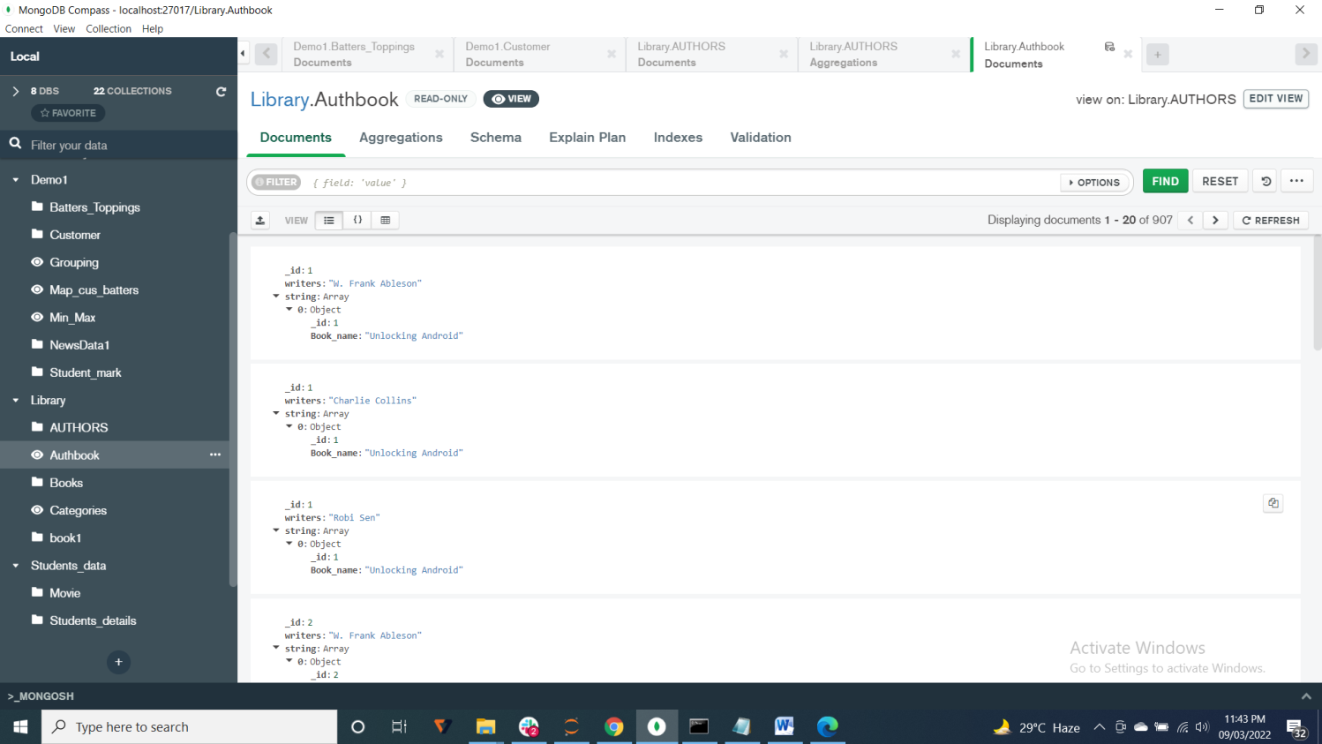

**TASK 10:-**

**#distinct categories of books**

Created a view named Categories.

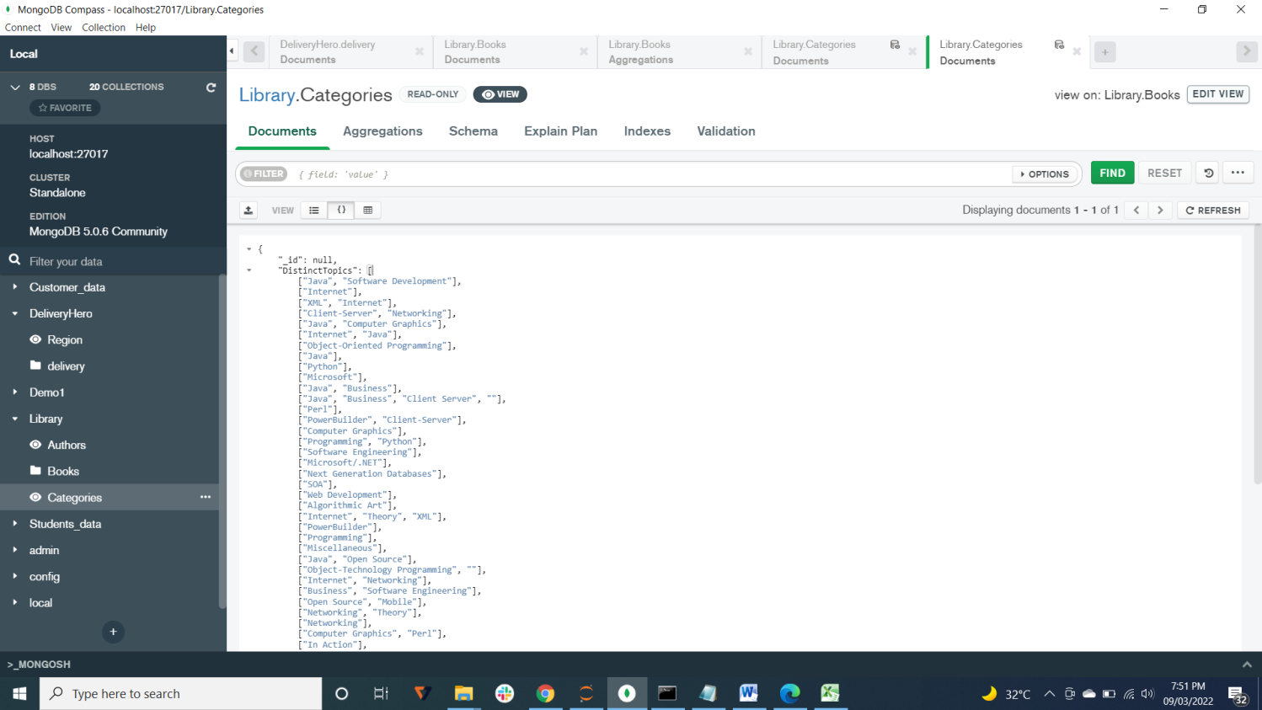

**TASK 11:-**

**#Min and Max page count**

Select🡪$group

*{*

*_id: null,*

*min_page_count:{'$min':'$pageCount'},*

*max_page_count:{'$max':'$pageCount'}*

*}*

Minimum page count=0

Maximum page count=1101